Q: How do I prevent people from deleting tabs in Excel workbooks?
A: Protect the workbook. This will allow people to enter/change data in the cells (including adding or deleting rows and columns) but not add or delete tabs.

Step 1: In the “Review” tab, click on “Protect Workbook”

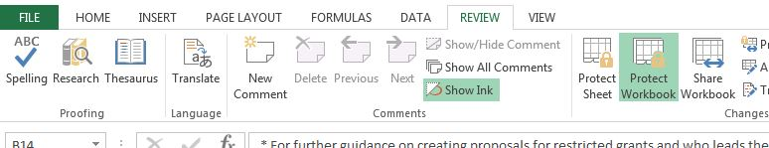

Step 2: In the pop-up box that appears, ensure that the checkbox next to “Structure” is selected.

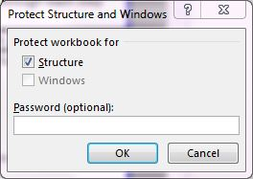
Enter a password if you desire, but be sure to write it down somewhere in case you need it in future. If you enter a password, a second pop-up box will appear asking you to re-enter the password.

Save the sheet.

If you want to undo the protection, click “Protect Workbook” again. If you entered a password, you’ll have to enter the password again to proceed.

Q: How do I lock cells in the Results Framework, Logframe, M&E Matrix or other tabs so that only Program Managers can change them?

A: Protect the sheets where the information is stored. Since the Project Design Workbooks and Detailed M&E Plans are already linked so that information entered in one tab is populated in others, you will have to protect all the sheets individually.

Step 1: Enter all the information that you want to protect in the relevant cells.

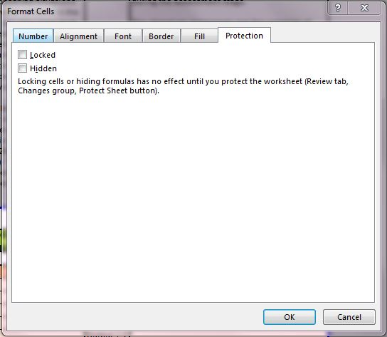
Step 2: Determine which (if any) cells you want to keep unlocked. Select the desired cell(s) and right click and select “Format Cells.” In the pop-up box that appears, select the “Protection” tab and unselect the “Locked” checkbox. Click “OK.” Repeat for all cells that you desire to keep unlocked on this sheet.

Step 3: Once all the cells that should not be locked have been selected, go to the Review tab at the top ribbon and click on “Protect Sheet.”

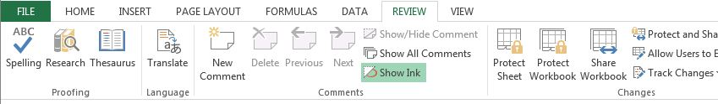

A pop-up box that looks like this will appear.
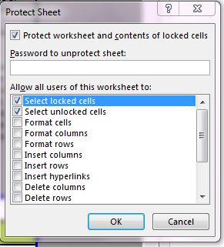

Enter a password (and write it down you remember it later) and select all the functions that you want users to be able to perform. They will not be able to interact at all with the information contained in cells (such as indicators) but you can give or remove their permission to format, add/delete rows, add/delete columns, etc. They will be able to enter/delete information in all the unlocked cells. Click “OK.” You will have to enter the password again to complete the protection. Don’t forget to save the workbook.

Suggestions:
You may want to keep ‘Select locked cells’ and ‘Select unlocked cells’ selected because disabling them can make the workbook difficult to use.

You may want to select ‘Insert rows’ and ‘Delete rows’ so that partners can add or delete activities underneath Indicators. You may want to unselect ‘Insert columns’ and ‘Delete columns’ so they cannot change the information required in the Logframe or M&E Matrix.

